Requirements:

1. Windows 10 PC with Python >= 3.7
2. Use 7zip (download from <https://www.7-zip.org/>) to unzip the image file.
3. Win32 Disk Imager (download from <https://sourceforge.net/projects/win32diskimager/> )

Installation files are also provided.

**Use Win32 Disk Imager to write the image file to microSD card.**

* 1. Open **Win32 Disk Imager**. Select the Firmware Image file. Select the micro-SD card device.

***NOTE***: Ensure the correct version of the FW is being selected prior to loading image.

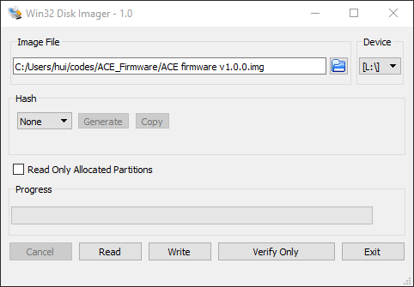

* 1. Click Write. Wait until writing is done. Click OK.

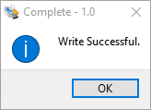

* 1. Remove microSD card from SD card reader.

**Use “SD Card utility” Script to write Device ID to the SD card.**

1. Double click “SD card utility.bat” to start the script.

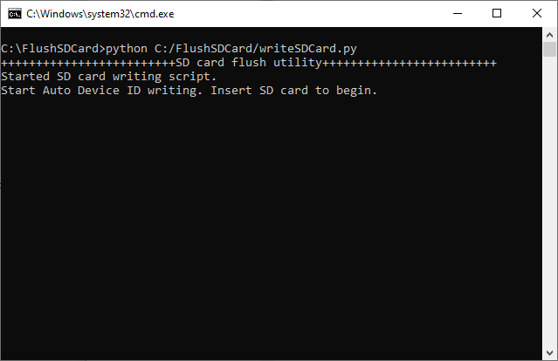

1. Insert the SD card that has the image file loaded from above to the SD card reader.
2. The script will detect the SD card has inserted and write “device_id.json” file to the SD card.

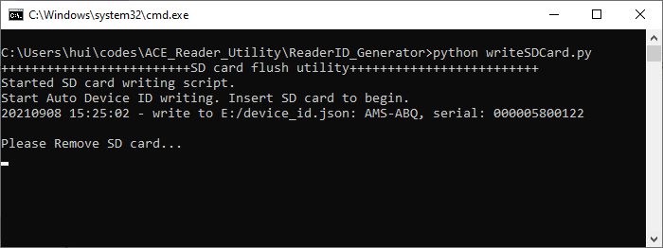

**Device ID**

1. Record the Device ID, in the figure above, the device ID is **AMS-ABQ.**
2. Unplug the microSD card from card reader. The script window will show SD card is removed and it is ready for next sensor insertion.

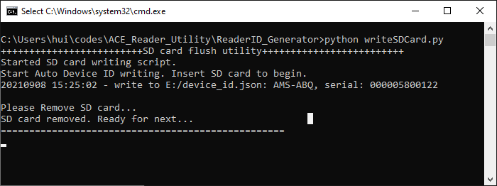

1. Create a label that includes the Device ID# and place the label on the 24 POS connector shown below. Insert the microSD card with the same Device ID to the Pi SD card slot.

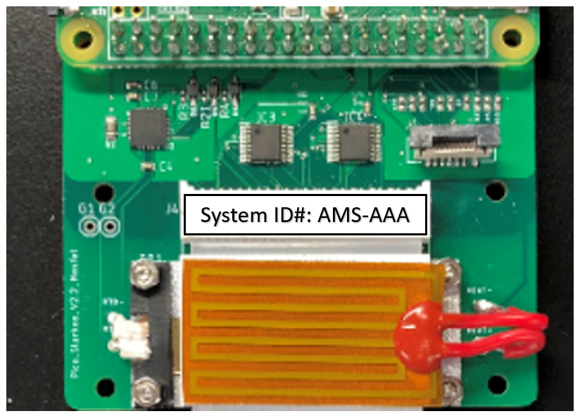

1. When a microSD card that already has the “device_id.json” file is inserted, the script will show the existing Device ID on the microSD card. User can enter “y” to confirm overwrite the device ID file with a new ID, or enter “n” to skip overwrite and remove the SD card.

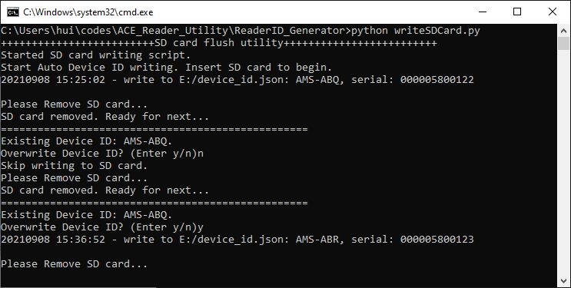

Tips:

1. On windows 10, if you click away in the script window, then the cursor will move to some other place, and the script window will not show text properly. You can resize the window by drag on the window corner to solve this problem.

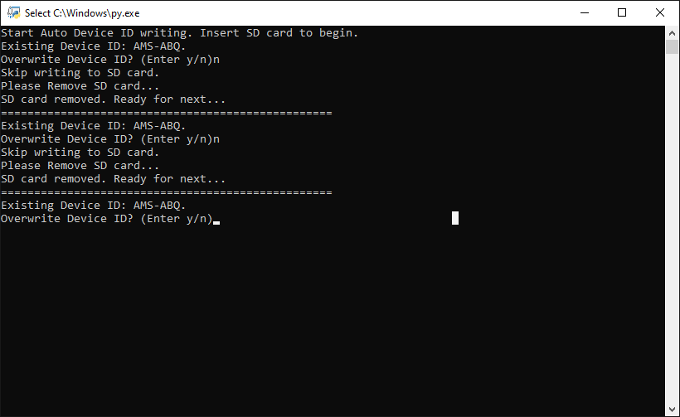

**Resize the window by dragging here will solve the problem.**

**Cursor moved here. New message will not display correctly**